John W. Robinson, IV
(1950-2011)

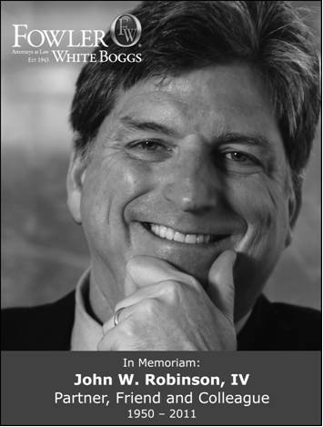
Inaugural Inductee into the Labor and Employment Law Section Hall of Fame June 2012

John W. Robinson, IV was born in Atlanta on April, 29, 1950, the son of John William Robinson III and Elizabeth Smith Robinson. He proudly attended Washington & Lee University, editing the college newspaper and serving as an officer of Pi Kappa Alpha and Omicron Delta Kappa.
There John received his army commission.

After attending law school at the University of Georgia, John worked as an attorney with the National Labor Relations Board in his beloved city of New Orleans. Shortly after their wedding in 1976, John and Ellen left for Mainz, Germany, where John served three years as defense counsel and then chief prosecutor with the First Brigade, Eighth Infantry as a Judge Advocate. John entered private practice with Fowler White Boggs in its Tampa office in 1980. There he served as firm secretary, board member, department head and firm counsel. He chaired the American Bar Association’s and The Florida Bar’s Labor and Employment Law Committees or Sections, and the Trial Lawyers Section of the Hillsborough County Bar Association.

He was past president of the C.H. Ferguson & M.E. White Tampa Chapter of the American Inns of Court, and was privileged to serve two terms as a member of the National Board of Trustees for the American Inns of Court Foundation. Among his many honors, John was listed in Best Lawyers of America, Top 10 Florida Super Lawyers and Florida Trend Magazine’s Florida Legal Elite 2004-2010. In 1996, he was inducted as a Fellow in the inaugural class of the prestigious College of Labor and Employment Lawyers.

Committed to his community, John was elected as the [standing] Commodore of the Tampa Yacht and Country Club. He served as chairman of the Alumni Board for Washington & Lee University and later served two terms on the University’s Board of Trustees. He was general counsel to the Greater Tampa Chamber of Commerce and a member of the Chamber’s Board of Directors.

John graduated from, and was very involved with, Leadership Tampa, serving on the Board of Directors as well as the Board for the Tampa Chapter’s Alumni organization. He was a graduate of Leadership Florida.

He served on multiple civic boards, including the Tampa Bay History Center, Berkeley Preparatory School, the University Club, the Board of Fellows for the University of Tampa, the Tampa Bay Rotary Club (past president), the Boy Scouts of America, and Northside Community Mental Health Center.

In addition to these many accomplishments, John led the Labor and Employment Law Section into an era of tremendous growth in membership with a strong and continuing commitment to quality continuing legal education. He was a moving force behind the camaraderie that is now a hallmark of our Section. Among other initiatives, he established the now-traditional cocktail hour, open to all Section members, after each Executive Council meeting.

2

