Gloria Fletcher
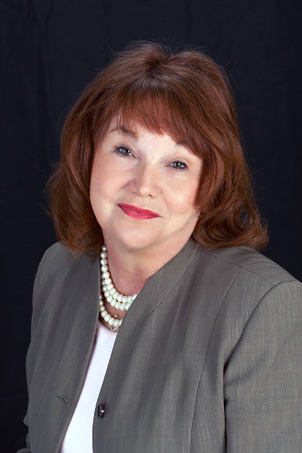
Inducted into the Labor and Employment Law Section Hall of Fame June 2017

Gloria Fletcher is the first woman to be inducted into the Labor & Employment Law Section’s Hall of Fame. Born in Tulsa, Oklahoma and raised in Gainesville, Florida, Ms. Fletcher attended college in Raleigh, North Carolina, where she received her BA from Shaw University.

Gloria’s true passion was for children’s rights and advocacy, which is why she began her career in Florida’s Department of Health and Rehabilitative Services as a Mental Health Program Specialist and rose to the level of Program Supervisor and Program Coordinator. This same passion inspired her to enroll in the University of Florida’s College of Law, making Law her second calling.

After graduating from UF, Ms. Fletcher was appointed an Assistant State Attorney by then State Attorney Gene Whitworth and was quickly promoted to a felony caseload. Many have noted her knack for fashioning resolutions that both protected and served the community and addressed the individual circumstances of each case and defendant.

In 1990, Gloria entered private practice, ultimately starting her own firm in 2004. As both a criminal defense attorney and an employment lawyer, she became renowned for her effective representation of law-enforcement personnel and correction’s officers. At the same time, she continued advocating for Florida’s children, tirelessly campaigning to convince the legislature to provide attorneys for abused and disabled children.

Gloria Fletcher also served in many roles throughout her community, including being a Founding Member of the James C. Adkins, Jr. American Inn of Court, two appointments by Florida governors to serve on the 8th Judicial Circuit Judicial Nominating Committee and a gubernatorial appointment to serve on the 8th Judicial Circuit Grievance Committee. She also served on the Florida and 8th Judicial Circuit Criminal Defense Lawyers Association. Ms. Fletcher also remained active in the United Way, the Alachua County Juvenile Justice Committee, Partners for Adolescent Lifestyles and Florida’s Children First, a statewide group focused on the welfare of disadvantaged children.

Although her time amongst us was not long enough, she has left a lasting impact in the State of Florida.

